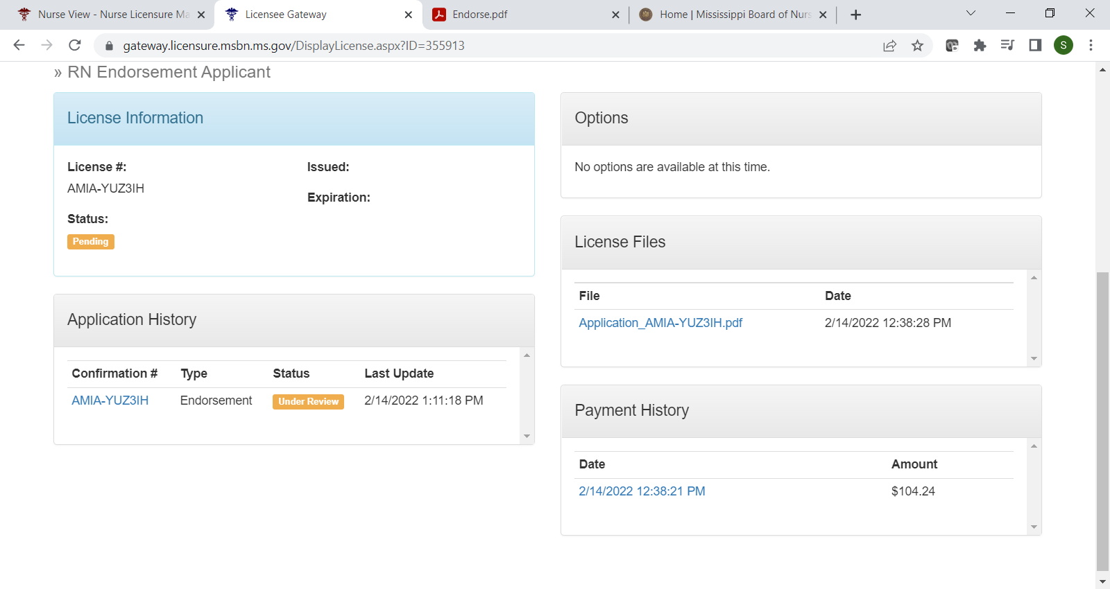
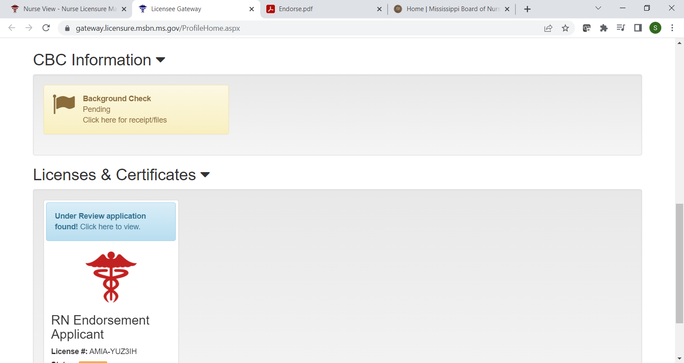
TO CHECK THE STATUS OF YOUR APPLICATION AND UPLOAD DOCUMENTS
Click here
Click here

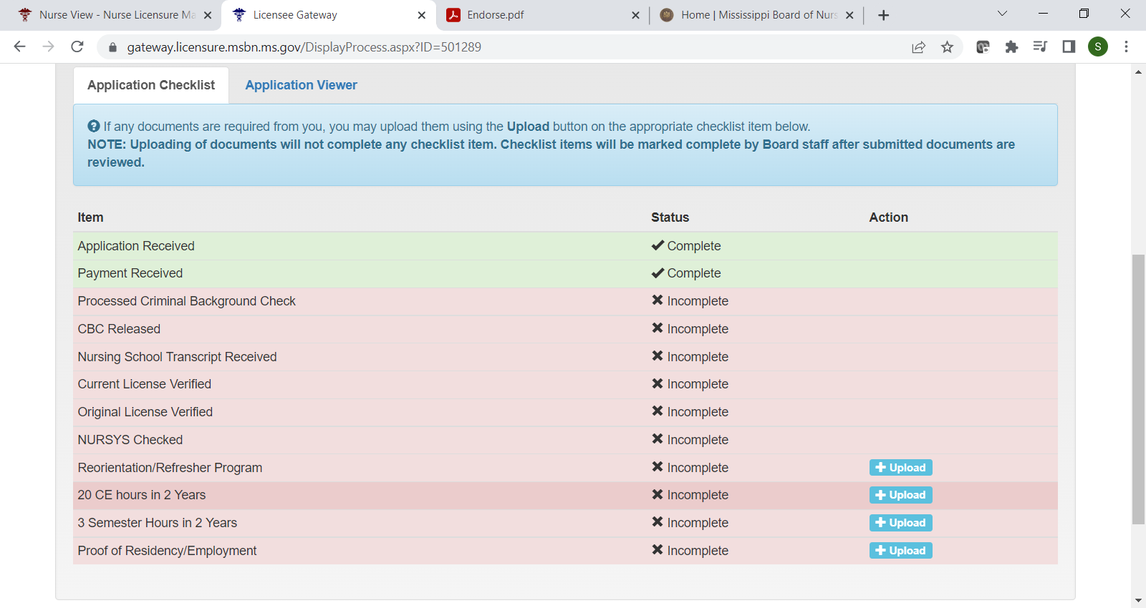

- If court documents are required, that checklist item will be in red with an upload button.
- If continued education is required, you can upload your documents on the appropriate line. Only 1 of the 3 options is required, if any.
- Proof of residency is required for all MS residents. Proof of employment may only be used to apply for a permit if MS is not your primary resident, but you will be working in MS.
- All other items may only be uploaded by a board staff member and will be marked complete once requirements have been met.
- It may take 7-10 business days to mark items complete/upload documents once received by the board so if you have just submitted your application most items will still show incomplete for up to 10 business days.

